**Exercise**

**Perform Fourier transform of signals**

Let the function f(x) be given with a period of 2π.

It is represented by the Fourier series converging in a given function in the interval (-π,π):



The coefficients of the series can be calculated using the formulas:







**Example 4.1.**

Expand the signal into a Fourier series with the number of terms 5, 10, 50, 100, 150, …

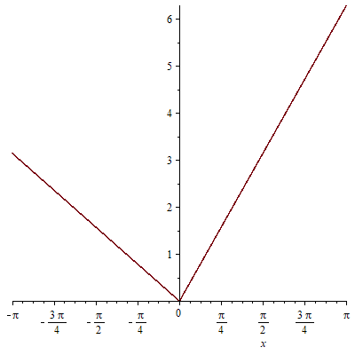



Determine the number of terms at which the signal shape is modeled satisfactorily.

**Example 4.2.**

Expand the signal into a Fourier series with the number of terms 5, 10, 50, 100, 150, …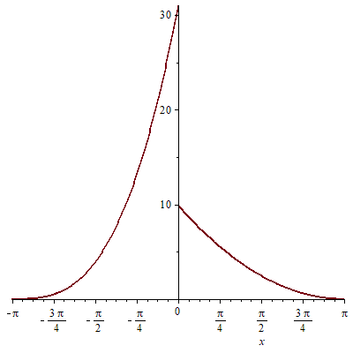



Determine the number of terms at which the signal shape is modeled satisfactorily.

**Example 4.3.**

Expand the signal into a Fourier series with the number of terms 5, 10, 50, 100, 150, …

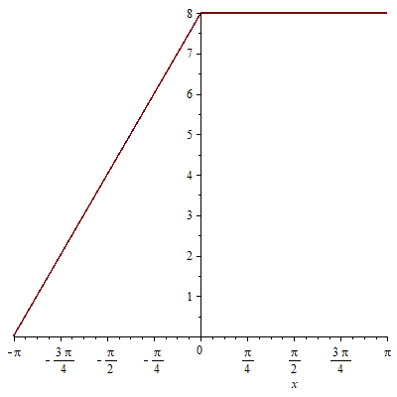



Determine the number of terms at which the signal shape is modeled satisfactorily.

**Example 4.4.**

Expand the signal into a Fourier series with the number of terms 5, 10, 50, 100, 150, …

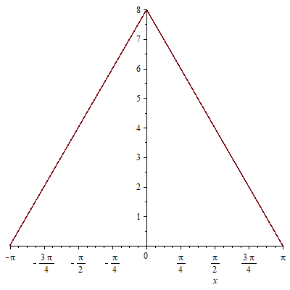



Determine the number of terms at which the signal shape is modeled satisfactorily.

**Example 4.5.**

Expand the signal into a Fourier series with the number of terms 5, 10, 50, 100, 150, …

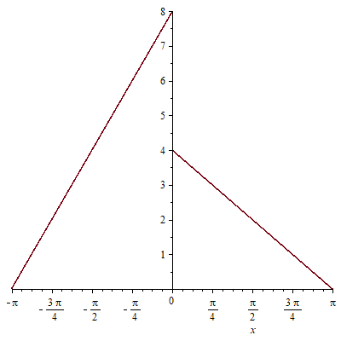



Determine the number of terms at which the signal shape is modeled satisfactorily.